Problem Set 7

SeungWha Lee

Xinyuan Meng

Boyang Pan

1. The 75 estimates of January mean returns are given in the table below.

|  |  |  |  |  |
| --- | --- | --- | --- | --- |
| Size | Past returns | January “extra” mean returns (t-stat) | | |
| **Past 1month return** | **Past 2-12month return** | **Past 13-60month return** |
| Small | **Low** | 8.41 (7.08) | 8.51 (7.25) | 8.33 (7.09) |
| **2** | 5.82 (5.52) | 6.31 (6.05) | 5.58 (5.45) |
| **3** | 4.93 (4.88) | 5.2 (5.32) | 4.15 (4.3) |
| **4** | 4.61 (4.63) | 4.33 (4.4) | 5.45 (5.22) |
| **High** | 4.05 (4.01) | 4.12 (4.24) | 4.52 (4.57) |
| 2 | **Low** | 4.64 (4.46) | 4.82 (4.46) | 4.98 (4.68) |
| **2** | 3.6 (4.15) | 3.79 (4.21) | 3.42 (3.74) |
| **3** | 2.82 (3.4) | 2.87 (3.58) | 2.54 (3.04) |
| **4** | 2.62 (3.07) | 2.23 (2.78) | 1.99 (2.28) |
| **High** | 1.97 (2.24) | 2.01 (2.33) | 1.99 (2.14) |
| 3 | **Low** | 3.57 (3.83) | 3.58 (3.43) | 4.23 (4.17) |
| **2** | 2.75 (3.44) | 2.49 (2.96) | 2.4 (2.83) |
| **3** | 2.2 (2.92) | 2.04 (2.7) | 2.05 (2.63) |
| **4** | 1.81 (2.54) | 1.49 (2.16) | 1.42 (1.91) |
| **High** | 0.78 (0.95) | 1.13 (1.47) | 1.33 (1.69) |
| 4 | **Low** | 2.27 (2.56) | 2.57 (2.46) | 2.64 (2.78) |
| **2** | 1.88 (2.57) | 1.74 (2.17) | 1.48 (1.87) |
| **3** | 1.55 (2.31) | 1.22 (1.74) | 1.21 (1.62) |
| **4** | 0.62 (0.87) | 0.62 (0.91) | 0.89 (1.24) |
| **High** | 0.02 (0.02) | 0.29 (0.4) | 0.35 (0.46) |
| Big | **Low** | 1.16 (1.51) | 1.99 (2.12) | 1.99 (2.84) |
| **2** | 0.72 (1.17) | 1.11 (1.54) | 0.8 (1.22) |
| **3** | 0.19 (0.33) | 0.27 (0.43) | 0.4 (0.62) |
| **4** | 0.15 (0.25) | -0.1 (-0.17) | -0.12 (-0.19) |
| **High** | -0.4 (-0.59) | -0.63 (-0.98) | -0.44 (-0.66) |

Below are the statistics of January dummy:

|  |  |  |  |  |  |
| --- | --- | --- | --- | --- | --- |
|  | mean | Standard error of mean | t-stat | Max | Min |
| $$β_{January}$$ | 2.5375 | 0.2401 | 10.5669 | 8.5095 | -0.6331 |

* Yes, there is a strong January seasonal effect that is different than other months.
* The large seasonality appears among small losers, and the small seasonality appear among big winners. More specifically, the 50th portfolio (big size, high past 2-12 month return) has the smallest seasonality and the 26th portfolio (small size, low past 2-12 month return) has the largest seasonality.
* There’re several possible explanations for January effect:
  + First, because of the tax consideration, many investors may choose to sell losers in December in order to realize capital losses and offset taxes on both gains and income. It is also known as “tax-loss harvesting”. In January, investors may repurchase those stocks, which could make stock prices higher in January.
  + A second explanation is that investors receive cash bonus at the end of the year, and invest in January for the new year, which causes the great increase in the equity market.
  + The third reason is usually called “window dressing”, which refers to a deceptive behavior of mutual fund managers. Fund managers may buy past winners and sell past losers at the end of the year, and thus the portfolio listed in annual report looks good to the fund investors. In January, they will buy back the stocks they used to hold, so some stocks exhibit great returns.

1. The 75 estimates of December mean returns are given in the table below.

|  |  |  |  |  |
| --- | --- | --- | --- | --- |
| Size | Past returns | December “extra” mean returns | | |
| **Past 1month return** | **Past 2-12month return** | **Past 13-60month return** |
| Small | **Low** | -0.33 (-0.28) | -1.18 (-1) | -0.28 (-0.23) |
| **2** | 0 (0) | -0.51 (-0.49) | 0.07 (0.07) |
| **3** | -0.29 (-0.29) | -0.52 (-0.53) | 0.25 (0.26) |
| **4** | -0.54 (-0.54) | 0.11 (0.12) | -0.02 (-0.02) |
| **High** | -0.12 (-0.12) | 1.07 (1.1) | 0.65 (0.65) |
| 2 | **Low** | 0.78 (0.75) | -0.19 (-0.17) | 0.84 (0.78) |
| **2** | 0.84 (0.96) | 0.43 (0.48) | 1.06 (1.15) |
| **3** | 0.79 (0.94) | 0.97 (1.2) | 1.1 (1.3) |
| **4** | 1.1 (1.28) | 1.45 (1.8) | 0.8 (0.91) |
| **High** | 1.09 (1.24) | 1.6 (1.83) | 0.69 (0.73) |
| 3 | **Low** | 1.23 (1.31) | 0.58 (0.55) | 1.55 (1.51) |
| **2** | 0.96 (1.19) | 0.74 (0.87) | 1.18 (1.38) |
| **3** | 1.2 (1.59) | 0.91 (1.19) | 1.53 (1.95) |
| **4** | 1.27 (1.78) | 1.49 (2.15) | 0.91 (1.21) |
| **High** | 1.28 (1.55) | 1.97 (2.56) | 0.92 (1.15) |
| 4 | **Low** | 1.14 (1.29) | 0.16 (0.15) | 0.83 (0.86) |
| **2** | 0.99 (1.35) | 0.68 (0.84) | 1.09 (1.37) |
| **3** | 1.49 (2.21) | 0.92 (1.3) | 1.27 (1.68) |
| **4** | 1.12 (1.57) | 1.4 (2.05) | 1.27 (1.74) |
| **High** | 1.32 (1.67) | 2.11 (2.92) | 1.21 (1.58) |
| Big | **Low** | 0.63 (0.81) | -0.39 (-0.41) | 1.05 (1.49) |
| **2** | 0.78 (1.25) | -0.04 (-0.06) | 0.98 (1.48) |
| **3** | 0.92 (1.57) | 0.61 (0.94) | 0.7 (1.08) |
| **4** | 0.92 (1.52) | 1.02 (1.73) | 0.87 (1.38) |
| **High** | 0.6 (0.88) | 1.48 (2.27) | 0.71 (1.06) |

Below are the statistics of January & December dummies:

|  |  |  |  |  |  |
| --- | --- | --- | --- | --- | --- |
|  | mean | Standard error of mean | t-stat | Max | Min |
| $$β_{January}$$ | 2.6066 | 0.2358 | 11.0555 | 8.4027 | -0.4999 |
| $$β_{December}$$ | 0.7634 | 0.0734 | 10.4009 | 2.1052 | -1.1821 |

* Yes, there is a strong January and December seasonal that is different than other months and different than each other.
* The large January seasonality appear among small losers, and the small January seasonality appear among big winners. More specifically, the 50th portfolio (big size, high past 2-12 month return) has the smallest seasonality and the 26th portfolio (small size, low past 2-12 month return) has the largest seasonality.
* The large December seasonality are among big winners, and the small December seasonality appear among small losers. More specifically, the 26th portfolio (small size, low past 2-12 month return) has the smallest seasonality and the 45th portfolio (size 4, high past 2-12 month return) has the largest seasonality.
* There are several possible explanations for the differences:
  + First, because of tax considerations, investors tend to sell losers in order to offset realized capital gains and deduct tax in December. In January, investors may repurchase those stocks. The sell-offs in December may lead to a price decrease of past losers and an increase of past winners.
  + The second explanation is the “window dressing”. Fund managers may buy winners and sell losers at the end of the year, and thus the portfolio listed in annual report looks good to investors. Then they will repurchase losers in January. Thus, the past losers have a relatively low mean return in December while the past winners, on the contrary, have a relatively high mean return.

1. These findings above are against market efficiency; specifically, against weak-form market efficiency, because the results imply that we can systematically obtain positive abnormal return based on the past price information. If the market is truly weak-form efficient, all these anomalies should disappear as soon as at least one rational investor finds this out and takes advantage of it.

Yet, the results above may hold while the market is efficient. One case is where we observe frictions in the trading that are sufficiently significant to prevent prices being corrected by the rational investor. For example, if the transaction cost is too high or if there is some limit in taking short positions, one would not be able to gain profit on the opportunities that may seem obvious. Thus, the anomalies are persistent over time because investors cannot take advantage of them. Another case is that the models we assumed above are flawed or insufficient in explaining the world, the results would not be meaningful although we have statistical significance on our coefficient estimates. In general, a model with simple dummy variables on months is less likely to explain the world perfectly. It is possible that these dummies are no longer statistically significant when we take some common factors into our models.

1. Below are the statistics of coefficients:

|  |  |  |
| --- | --- | --- |
|  | mean | t-statistic |
| $$β_{1-month}$$ | 0.0598 | 5.3551 |
| $$β_{12-month}$$ | 0.0209 | 7.0272 |
| $$β_{60-month}$$ | 0.0060 | 5.7417 |

The coefficients we estimated here indicate that past performances, regardless of their time horizons, have positive predictability in future returns. This is a violation of the weak-form market efficiency, since, if this is true, we can exploit positive abnormal returns using historical data.

Yet, market efficiency hypothesis is a joint hypothesis where both the response to information and the model used to explain the world are tested at the same time. It is likely that the model we used to estimate the coefficients are flawed, providing misleading results for interpretation. It could be the case that, if we add appropriate factors to the model, the sign or the statistical significance on some of the coefficients may change, especially for $β_{60-month}$. It may also be the case where, due to market imperfections – transaction costs, constraints in trading, etc. – the abnormal returns persist, but cannot be exploited without significant costs.

1. Using the 75 given portfolios based on past performances and size, I created a zero-cost winners-minus-losers portfolio (the usual UMD portfolio) that takes certain long-short positions on Januaries and Decembers. The intuition behind this strategy comes from the results in a), b), and d), that there are seasonal effects in Januaries and Decembers for certain portfolios and that past returns do have predictive power, regardless of their horizon.

$$r_{it}-r_{ft}=β_{0}+β_{i}^{JAN}1_{\left\{January\right\}}+β_{i}^{DEC}1_{\left\{December\right\}}+ϵ_{it}$$

$$r_{it}=γ_{0}+(γ_{1}*r_{it-1})+(γ_{2}*\sum_{j=2}^{12}{r_{it-j}})+(γ_{3}*\sum_{j=13}^{60}{r_{it-j}})+ε_{it}$$

The construction is as follows:

* In Januaries:
  + Long 18 portfolios with the 18 largest January betas, each weighted on the size of their betas (i.e. $\frac{β_{i}^{JAN}}{\sum_{j=1}^{18}{β_{j}^{JAN}}}$)
  + Short 18 portfolios with the 18 smallest January betas, each weighted on the size of their betas (i.e. $\frac{β_{i}^{JAN}}{\sum_{j=1}^{18}{β_{j}^{JAN}}}$)
* In Decembers:
  + Long 18 portfolios with the 18 largest December betas, each weighted on the size of their betas (i.e. $\frac{β_{i}^{DEC}}{\sum_{j=1}^{18}{β_{j}^{DEC}}}$)
  + Short 18 portfolios with the 18 smallest December betas, each weighted on the size of their betas (i.e. $\frac{β_{i}^{DEC}}{\sum_{j=1}^{18}{β_{j}^{DEC}}}$)
* Between February to November:
  + Long 3 portfolios with the largest returns on the past month (short-term momentum), 3 portfolios with the largest cumulative returns on the past 2-12 months (intermediate-term momentum), and 3 portfolios with the largest cumulative returns on the past 13-60 months (long-term momentum)
  + Short 3 portfolios with the smallest returns on the past month, 3 portfolios with the smallest cumulative returns, and 3 portfolios with the smallest cumulative returns on the past 13-60 months

The resulting strategy has the following profile:

|  |  |
| --- | --- |
| Monthly return (%) | 0.6677 |
| Monthly volatility (%) | 2.4855 |
| Annualized Sharpe Ratio | 0.9305 |

This seems like a decent performance overall, considering that the annualized Sharpe Ratio of the market portfolio is approximately 0.4.

1. The following table summarizes the upper and lower bounds of the annualized Sharpe Ratio computed in e) with and without the normal distribution assumption at a 95% confidence level. The slightly narrower confidence interval in the general case may be attributed to the large value in the skewness of the distribution of our strategy.

|  |  |  |
| --- | --- | --- |
|  | Lower Bound | Upper Bound |
| Normal Distribution | 0.7124 | 1.1477 |
| General Case | 0.8052 | 1.0549 |

1. The histogram below illustrates the t-statistics of the gross returns of the random-picking strategy. As clearly shown, in all cases, the t-stats of returns are all greater than 2.

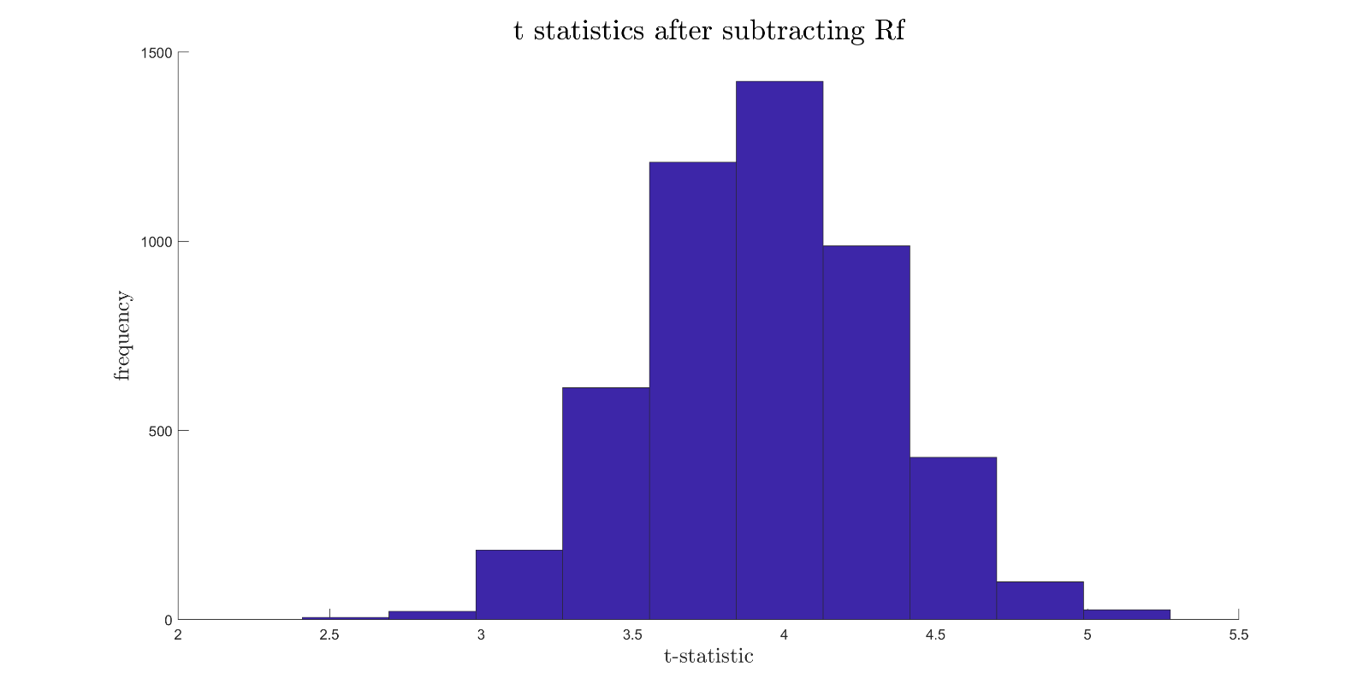Note that 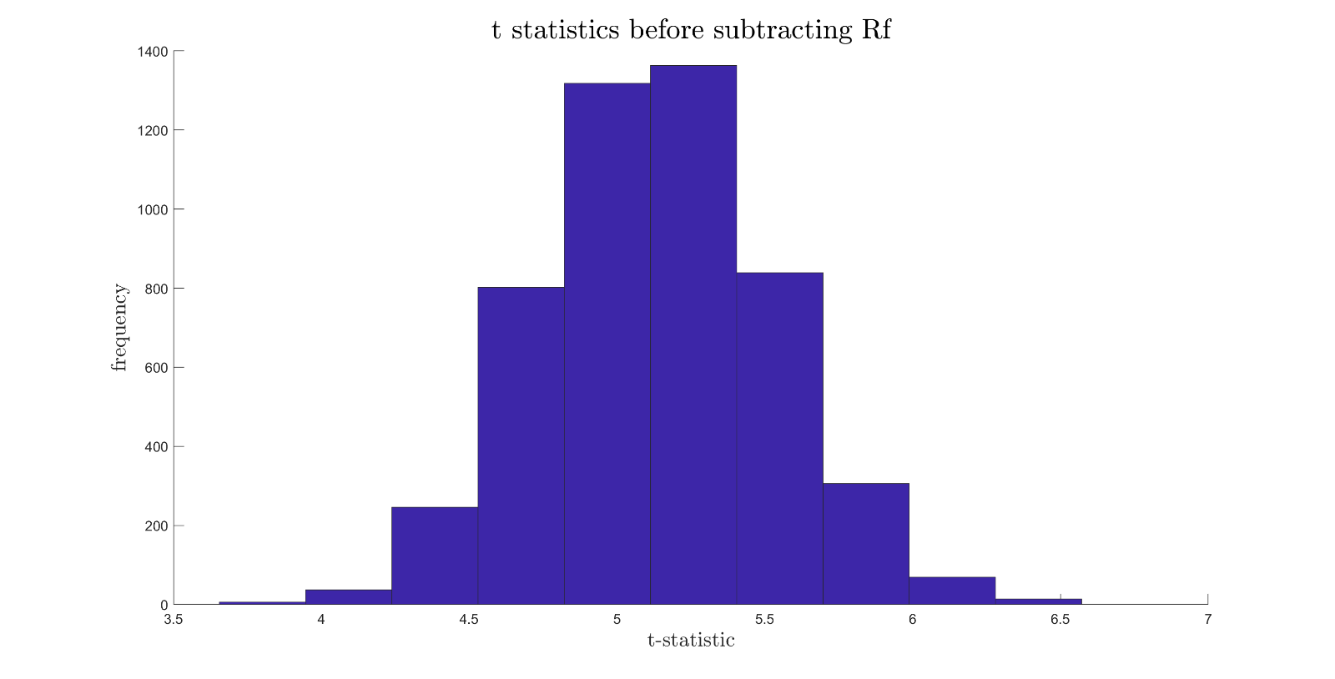the results are still significantly greater than zero after we subtract the risk-free rate as the histogram below shows:

This is not too surprising since the strategy as an aggregate should resemble the market portfolio. Since we have run 5,000 times, the average of these 5,000 results is expected to be an unbiased estimate of the market portfolio. This is because the random-picking of the 75 portfolios should in a way diversify away any of the idiosyncratic risk there is, leaving only the systemic risk. With only the systematic risk left, the portfolio should resemble the market portfolio.

We can check this by examining the distribution of the Sharpe Ratios of the random-picking simulations. The last histogram below shows that the numbers are centered around approximately 0.4; mean of 0.4171 and a standard deviation of 0.0415. This is quite close to the long-run Sharpe Ratio of S&P 500, 0.4186, so the random strategy is a typical proxy for the market.

However, we do not conclude that the random strategy that delivers performance. In reality, we have to consider transaction costs. Because we change our holdings every month, the frequent transactions will generate high costs for us. Consequently, the return we generate will not as high as our simulation results, which ignores transaction cost.

* 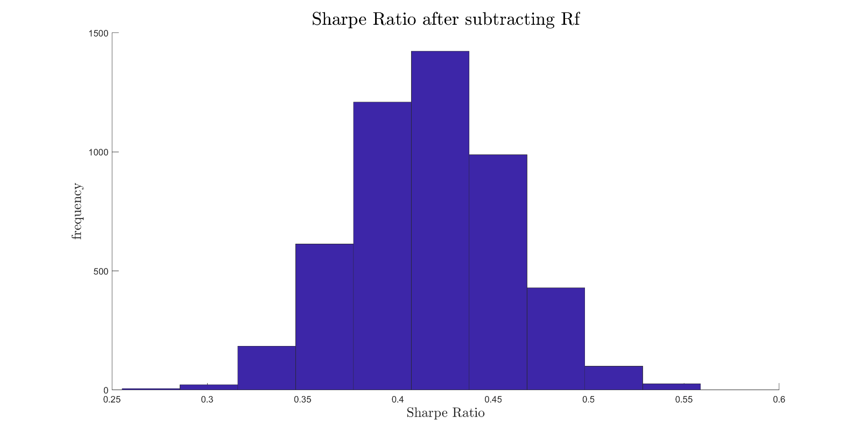The maximum Sharpe Ratio of these random strategies is 0.5587, which is smaller than our Sharpe Ratio of the strategy we created in e), so 0% of these random strategies are larger than the strategies.
* The upper bound of the confidence intervals are 1.1477 and 1.0549 under normal distribution and general case respectively. Therefore, 0% of these random strategies are larger than the upper part of the confidence intervals.
* Our answer highlights the danger of transaction cost. As we mentioned above, the transaction costs will lower the returns if we frequently buy and sell stocks, so we should be cautious when we backtest our strategies without considering the transaction costs.